Name: Manit Mishra
Date: 3/20/2022
08.07 Picture Lab Worksheet
Directions: Make note of your responses to the following questions as you work through the activities and exercise in the lesson.
Activity 5 Questions
Question | Yes | No
- Is the method getPixels2D in the Picture.java class? |  | No
- Is the method getPixels2D in the SimplePicture.java class? | Yes
- Will the following code compile?  DigitalPicture p = new DigitalPicture(); |  | No
- Assuming a no-argument constructor exists for SimplePicture, will the following code compile?  DigitalPicture p = new SimplePicture(); | Yes
- Assuming a no-argument constructor exists for Picture, will the following code compile?  DigitalPicture p = new Picture(); | Yes
- Assuming a no-argument constructor exists for Picture, will the following code compile?  SimplePicture p = new Picture(); | Yes
- Assuming a no-argument constructor exists for SimplePicture, will the following code compile?  Picture p = new SimplePicture(); |  | No

Activity 5 Exercise Results

- Describe your method for keepOnly red, blue, or green.

When I made the keepOnlyRed method, all of the pixels on the screen turned into red.
- For the negate method, paste your code related to calculating and setting the values for red, blue, and green.

public static void testNegate(){
Picture beach = new Picture("beach.jpg");
beach.explore();
beach.negate();
beach.explore();
}
- Paste a copy of the image that is the result of calling the grayscale.

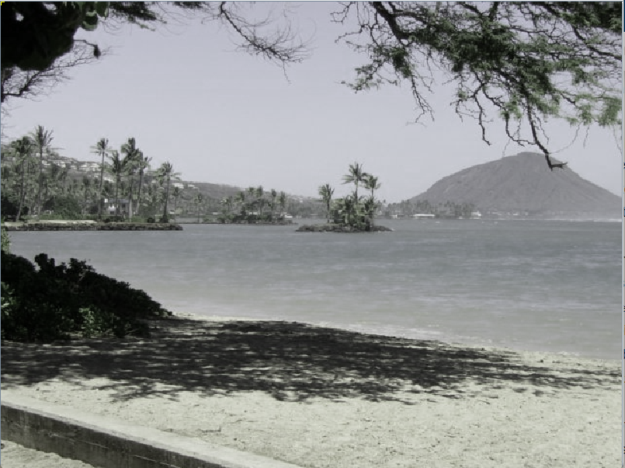
- For the method fixUnderwater, describe the algorithm you'd propose to accomplish the task.

I could not find the fish.jpg file in the images folder, but what I would Imagine I would do is increase the

Activity 6 Exercise Results
- Paste the image that is the result of calling the method mirrorVerticalRightToLeft.

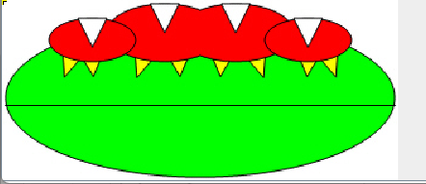
- Describe the algorithm for the method mirrorHorizontal works.

The for loop starts off at a column, and then in that column it goes through the first half of the rows. It then sets the top pixel depending on the row and column location. It then sets the bottom pixel location depending on its distance form the end with width-1-row. Then you set the bottom pixel to the top pixel color.
- Paste the image that is the result of calling the method mirrorHorizontalBotToTop.

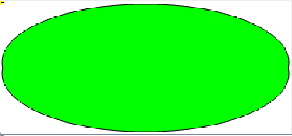

Activity 7 Questions
  - How many times would the body of this nested for loop execute? _90 times_
for(int row = 7; row < 17; row++)
for(int col = 6; col < 15; col++)

  - How many times would the body of this nested for loop execute? _112 times_
for(int row = 5; row <= 11; row++)
for(int col = 3; col <= 18; col++)

Activity 7 Exercise Results

- What value is displayed for count after the nested loop ends in the mirrorTemple method? _count = 18,410_
- Paste the image that is the result of calling the method mirrorArms.

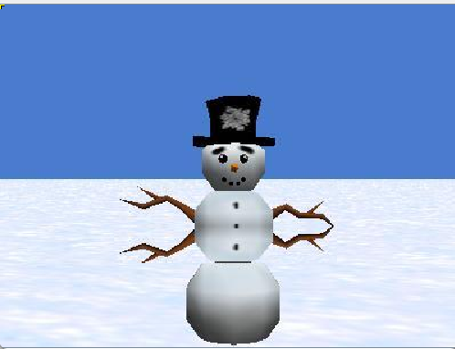
- Paste the image that is the result of calling the method mirrorGull
